**A PROJECT REPORT**

**ON**

**“LEARNING SYSTEM”**

**SUBMITTED TO**

**MS. ISHA**

**SUBMITTED BY:-**

**NAVEED FAROOK**

**Roll no:- 63**

**SURAJ**

**Roll no:- 62**

**BACHELOR OF TECHNOLOGY**

**DEPARTMENT OF COMPUTER SCIENCE ENGINEERING**

**LOVELY PROFESSIONAL UNIVERSITY**

**ACKNOWLEDGEMENTS**

We would like to express my heartfelt gratitude to **Ms.Isha** for giving the opportunity to work under her guidance and help us gain immensely enriching professional experience. Our sincere thanks to project in charge and our internal project guide for giving us valuable inputs and ideas right from the selection of topic for project until its successful completion.

The successful completion of our project would not have been possible without the dedicated support from all our mentors, family and friends.

**DESIGN AND SOURCE CODE**

**Main source code:**

<!DOCTYPE html>

<html lang="en">

<head>

<link rel="stylesheet" href="style.css">

<title>Document</title>

</head>

<body>

<div class="main">

<header class="head">

<h1>E - Learning System</h1>

</header>

<div class="login">

<ul>

<li><span class="b"><a href="login page.html">LOGIN</a></span></li>

</ul>

</div>

<div class="list">

<ul>

<li class="dropdown"><a href="#" class="dropbtn">Home</a>

<li class="dropdown1"><a href="javascript:void(0)" class="dropbtn1">Subject-Videos</a>

<div class="dropdown-content1">

<a href="https://www.youtube.com/channel/UCJ0yBou72Lz9fqeMXh9mkog">Physics</a><br>

<a href="https://www.transum.org/Software/SW/YouTube/">Maths</a><br>

<a href="https://www.khanacademy.org/science/chemistry">Chemistry</a><br>

<a href="https://www.ibiology.org/biology-videos/">Biology</a><br>

</div>

</li>

<li><a href="tutors list.html">Tutors</a></li>

<li><a href="#">Take Test</a></li>

<li><a href="about.html">Contact Us</a></li>

</ul>

</div>

<div class="flex1">

<div class="h2">

<h2>Subjects</h2>

<li class="dropdown1"><a href="javascript:void(0)" class="dropbtn1">PHYSICS</a>

    <div class="dropdown-content1">

    <a href="https://csm.rowan.edu/departments/physics/current/course_topics.html">Qauntum Theory</a><br>

    <a href="https://www.sciencedirect.com/topics/computer-science/electromagnetic-theory">Electromagnetic Theory</a><br>

    <a href="https://www.britannica.com/science/Newtons-laws-of-motion">Newtons Law</a><br>

    <a href="https://byjus.com/jee/solid-state/">Solid State</a><br>

    <a href="https://en.m.wikipedia.org/wiki/Diffraction#:~:text=Diffraction%20is%20defined%20as%20the,source%20of%20the%20propagating%20wave.">Diffraction</a><br>

    </div>

    </li>

</div>

<div class="ank">

    <link rel="stylesheet" href="style.css">

    <div class="about-section">

        <div class="inner-width">

        <h1>Physics</h1>

        <div class="border"></div>

        <div class="about-section-row">

        <div class="about-section-col">

        <div class="about">

        <p>

        Quantum Mechanics: the branch of mechanics that deals with the mathematical description of the motion and interaction of subatomic particles, incorporating the concepts of quantization of energy, wave–particle duality, the uncertainty principle, and the correspondence principle.

        Classical physics, the collection of theories that existed before the advent of quantum mechanics, describes many aspects of nature at an ordinary (macroscopic) scale, but is not sufficient for describing them at small (atomic and subatomic) scales. Most theories in classical physics can be derived from quantum mechanics as an approximation valid at large (macroscopic) scale.[3]

Quantum mechanics differs from classical physics in that energy, momentum, angular momentum, and other quantities of a bound system are restricted to discrete values (quantization); objects have characteristics of both particles and waves (wave–particle duality); and there are limits to how accurately the value of a physical quantity can be predicted prior to its measurement, given a complete set of initial conditions (the uncertainty principle).

Quantum mechanics differs from classical physics in that energy, momentum, angular momentum, and other quantities of a bound system are restricted to discrete values (quantization); objects have characteristics of both particles and waves (wave–particle duality); and there are limits to how accurately the value of a physical quantity can be predicted prior to its measurement, given a complete set of initial conditions (the uncertainty principle).

        </p>

        </div>

        </div><!DOCTYPE html>

<html lang="en">

<head>

<link rel="stylesheet" href="style.css">

<title>Document</title>

</head>

<body>

<div class="main">

<header class="head">

<h1>E - Learning System</h1>

</header>

<div class="login">

<ul>

<li><span class="b"><a href="login page.html">LOGIN</a></span></li>

</ul>

</div>

<div class="list">

<ul>

<li class="dropdown"><a href="#" class="dropbtn">Home</a>

        </div>

        </div>

        </div>

        </div>

        </div>

</div>

</div>

<div class="faq"><form>

    <form>

        <a href="about.html"></a><input type="submit" value="About" class="faq-button" >

        <input type="submit" value="FAQ" class="faq-button">

    </form>

</form></div>

<footer>

    <p><a href="copyright.html">&#169; copyright</a></p>

</footer>

</body>

</html>

**Login page code:**

<!DOCTYPE html>

<html>

<head>

  <title>Login Page</title>

</head>

<body>

  <center> <h3>Login Here</h3>

      <table>

        <tr>

          <td>Username:</td>

          <td><input type="text" name="user" placeholder="Enter name Here"></td>

        </tr>

        <tr>

          <td>Password:</td>

          <td><input type="password" name="user_pass" placeholder="Enter Password Here"></td>

        </tr>

        <tr>

           <td><input type="submit" name="submit" value="Login"></td>

           <td><p>Not yet a Member? <a href="register.html">Register</a></p></td>

        </tr>

      </table>

    </form>

  </center>

</body>

</html>

**CSS Code:**

{

    margin: 0;

    padding: 0;

    }

    .main{

    background-image: url("253322.jpg");

    background-position: center;

    background-size: cover;

    background-position: initial;

    width: 100%;

    height: 150vh;

    }

    .head{

    font-size: 35px;

    text-align: center;

    color: rgb(204, 234, 238);

    text-shadow: 4px 6px #FF0000;

    border-radius: 10px;

    height: 90px;

    }

    .login{

    float: left;

    display: flex;

    width: 200px;

    color: coral;

    padding: 14px 15px;

    }

    .login ul{

    display: flex;

    float: left;

    align-items: center;

    padding: 25px;

    }

    .login ul li{

    list-style: none;

    margin-left: 280px;

    margin-top: 25;

    font-size: 14px;

    }

    .login ul li a{

    display: block;

    padding: 14px ;

    text-align: center;

    border-radius: 10px;

    font-size: 22px;

    color: coral;

    text-decoration: none;

    background-color: aliceblue;

    width: 96px;

    }

    .login ul li a:hover{

    background-color: none;

    font-size: 15px;

    color: black;

    text-decoration: none;

    background-color: burlywood;

    }

    .list{

    width: 200px;

    margin-left: 25;

    display: flex;

    padding: 14px;

    }

    .list ul{

    display: flex;

    float: left;

    align-items: center;

    padding: 14px;

    width: 10px;

    margin-left: 2px;

    margin-top: 70px;

    align-self: stretch;

    }

    .list ul li{

    text-align: center;

    list-style: none;

    /* margin-left: 70px; */

    margin-top: 25;

    font-size: 10px;

    display: grid;

    float: left;

    width: 180px;

    padding: 14px;

    }

    .list ul li a{

    display: grid;

    float: left;

    padding: 14px ;

    text-align: center;

    border-style: groove;

    font-size: 22px;

    color: coral;

    text-decoration: none;

    background-color: aliceblue;

    width: 226px;

    }

    .list li a, .dropbtn{

    display: inline-block;

    color: white;

    text-align: center;

    padding: 14px 16px;

    text-decoration: none;

    }

    .list li a:hover, .dropdown:hover .dropbtn{

    background-color: red;

    }

    .list li .dropdown{

    display: inline-block;

    }

    .list .dropdown-content{

    display: none;

    position: absolute;

    background-color: #f9f9f9;

    min-width: 160px;

    box-shadow: 0px 8px 16px 0px rgba(0,0,0,0.2);

    z-index: 1;

    }

    .dropdown-content a{

    color: black;

    padding: 12px 16px;

    text-decoration: none;

    display: block;

    text-align: left;

    }

    .dropdown-content a:hover {background-color: #f1f1f1;}

    .dropdown:hover .dropdown-content {

    display: block;

    }

    .list li a, .dropbtn1{

    display: inline-block;

    color: white;

    text-align: center;

    padding: 14px 16px;

    text-decoration: none;

    }

    .list li a:hover, .dropdown1:hover .dropbtn1{

    background-color: red;

    }

    .list li .dropdown1{

    display: inline-block;

    }

    .list .dropdown-content1{

    display: none;

    position: absolute;

    background-color: #f9f9f9;

    min-width: 160px;

    box-shadow: 0px 8px 16px 0px rgba(0,0,0,0.2);

    z-index: 1;

    }

    .dropdown-content1 a{

    color: black;

    padding: 12px 16px;

    text-decoration: none;

    display: block;

    text-align: left;

    }

    .dropdown-content1 a:hover {background-color: #f1f1f1;}

    .dropdown1:hover .dropdown-content1 {

    display: block;

    }

    .h2{

    font-size: 20px;

    background-color: burlywood;

    border-radius: 10px;

    width: 30%;

    }

    .form {

    font-size: 25px;

    padding: 36px;

    margin-top: 1px;

    height: 189px;

    }

    .form{

    color: coral;

    background-color: #f1f1f1;

    width: 250px;

    }

    .form input{

    padding: 10px;

    display: grid;

    }

    .about-section{

    width: 90%;

    background:#fff;

    padding: 15px ;

    margin-left: 5px;

    margin-right:auto;

    margin-top: 85px;

    box-shadow: rgba(0, 0, 0, 0.15) 0px 5px 15px 0px;

    border-radius: 30px;

    border-left: 50px solid #3CEDA7;

    border-right: 50px solid #3CEDA7;

    }

    .inner-width{

    max-width: 1000px;

    overflow: hidden;

    padding: 0 10px;

    margin: auto;

    }

    .about-section h1{

    text-align: center;

    }

    .border{

    width: 100px;

    height: 3px;

    background: #3CEDA7;

    margin: 40px auto;

    }

    .about-section-row{

    display: flex;

    flex-wrap: wrap;

    }

    .about-section-col{

    flex: 50%;

    }

    .about{

    padding-right: 30px;

    }

    .about p{

    text-align: justify;

    margin-bottom: 20px;

    color: #7E7C7A;

    font-size: 17px;

    }

    .ank{

    color: rgb(255, 116, 51);

    font-size: 25px;

    margin-left: 50px;

    margin-top: -83px;

    font-family: fantasy;

    }

    .about a{

    display: inline-block;

    color: #7E7C7A;

    text-decoration: none;

    border: 2px solid #3CEDA7;

    border-radius: 24px;

    padding: 8px 40px;

    transition: 0.4s linear;

    }

    .about a:hover{

    color: #fff;

    background: #3CEDA7;

    }

    .skills{

    padding-left: 30px;

    }

    .skill{

    margin-bottom: 10px;

    }

    .title{

    color: #7E7C7A

    }

    .progress{

    width: 100%;

    height: 12px;

background: #ddd;

border-radius: 12px;

}

.progress-bar{

height: 12px;

background: #3CEDA7;

border-radius: 12px;

}

.p1{

width: 90%;

}

.p2{

width: 70%;

}

.p3{

width: 50%;

}

.progress-bar span{

float: right;

margin-right: 6px;

line-height: 13px;

color: #fff;

font-size: 12px;

}

@media screen and (max-width:700px) {

.about-section-col{

flex: 100%;

margin: 10px 0;

}

.about,.skills{

padding: 0;

}

.about{

text-align: center;

}

}

.tn{

font-size: 30px;

background-color:yellow;

font-style: algerian;

width:15px;

margin-left: 600px;

}

.flex1{

    display: flex;

}

footer{

    background-color: #3CEDA7;

    text-align: center;

    padding-top: 5px;

    padding-bottom: 5px;

    font-size: 20px;

}

.faq{

    text-align: right;

    padding-top: 5px;

    padding-bottom: 5px;

    background-color: #FF0000;

    border-bottom: 10px;

    margin-bottom: 25px;

}

.faq-button{

    color: red;

    margin-left: 10px;

    margin-right: 10px;

    padding:15px;

    padding-left: 50px;

    padding-right: 50px;

    font-size: 20px;

}

About:

<link rel="stylesheet" href="style.css">

<div class="about-section">

    <div class="inner-width">

    <h1>About Us</h1>

    <div class="border"></div>

    <div class="about-section-row">

    <div class="about-section-col">

    <div class="about">

    <p>

        An online learning platform  that provide trainers, learners, and others involved in education with information, tools, and resources to support and enhance education delivery and management.<br>

        <br>

        Contact us - elearningedu@gmail.com

    </p>

    </div>

    </div>

Tutors:

<!DOCTYPE html>

<html>

    <title>tutor list</title>

<head>

    <style>

        p{

            background-color: aqua;

            color: black;

            font-size: 40px;

        }

    </style>

</head>

<body>

<p>Chemistry - Dr.Sreenivasan 8756474757 <br>

   Physics - Dr.Mukesh sindra 905893939 <br>

   Maths - Dr.Chandrashekhar 758485565 <br>

   Biology - Dr.Susheel 768578675

</p>

</body>

</html>

Code:

<!DOCTYPE html>

<html lang="en">

<head>

<link rel="stylesheet" href="style.css">

<title>Document</title>

</head>

<body>

<div class="main">

<header class="head">

<h1>E - Learning System</h1>

</header>

<div class="login">

<ul>

<li><span class="b"><a href="login page.html">LOGIN</a></span></li>

</ul>

</div>

<div class="list">

<ul>

<li class="dropdown"><a href="#" class="dropbtn">Home</a>

<li class="dropdown1"><a href="javascript:void(0)" class="dropbtn1">Subject-Videos</a>

<div class="dropdown-content1">

<a href="https://www.youtube.com/channel/UCJ0yBou72Lz9fqeMXh9mkog">Physics</a><br>

<a href="https://www.transum.org/Software/SW/YouTube/">Maths</a><br>

<a href="https://www.khanacademy.org/science/chemistry">Chemistry</a><br>

<a href="https://www.ibiology.org/biology-videos/">Biology</a><br>

</div>

</li>

<li><a href="tutors list.html">Tutors</a></li>

<li><a href="#">Take Test</a></li>

<li><a href="about.html">Contact Us</a></li>

</ul>

</div>

<div class="flex1">

<div class="h2">

<h2>Subjects</h2>

<li class="dropdown1"><a href="javascript:void(0)" class="dropbtn1">PHYSICS</a>

<div class="dropdown-content1">

<a href="https://csm.rowan.edu/departments/physics/current/course_topics.html">Qauntum Theory</a><br>

<a href="https://www.sciencedirect.com/topics/computer-science/electromagnetic-theory">Electromagnetic Theory</a><br>

<a href="https://www.britannica.com/science/Newtons-laws-of-motion">Newtons Law</a><br>

<a href="https://byjus.com/jee/solid-state/">Solid State</a><br>

<a href="https://en.m.wikipedia.org/wiki/Diffraction#:~:text=Diffraction%20is%20defined%20as%20the,source%20of%20the%20propagating%20wave.">Diffraction</a><br>

</div>

</li>

</div>

<div class="ank">

<link rel="stylesheet" href="style.css">

<div class="about-section">

<div class="inner-width">

<h1>Physics</h1>

<div class="border"></div>

<div class="about-section-row">

<div class="about-section-col">

<div class="about">

<p>

Quantum Mechanics: the branch of mechanics that deals with the mathematical description of the motion and interaction of subatomic particles, incorporating the concepts of quantization of energy, wave–particle duality, the uncertainty principle, and the correspondence principle.

Classical physics, the collection of theories that existed before the advent of quantum mechanics, describes many aspects of nature at an ordinary (macroscopic) scale, but is not sufficient for describing them at small (atomic and subatomic) scales. Most theories in classical physics can be derived from quantum mechanics as an approximation valid at large (macroscopic) scale.[3]

Quantum mechanics differs from classical physics in that energy, momentum, angular momentum, and other quantities of a bound system are restricted to discrete values (quantization); objects have characteristics of both particles and waves (wave–particle duality); and there are limits to how accurately the value of a physical quantity can be predicted prior to its measurement, given a complete set of initial conditions (the uncertainty principle).

Quantum mechanics differs from classical physics in that energy, momentum, angular momentum, and other quantities of a bound system are restricted to discrete values (quantization); objects have characteristics of both particles and waves (wave–particle duality); and there are limits to how accurately the value of a physical quantity can be predicted prior to its measurement, given a complete set of initial conditions (the uncertainty principle).

</p>

</div>

</div>

</div>

</div>

</div>

</div>

</div>

</div>

</div>

<div class="faq"><form>

<form>

<a href="about.html"></a><input type="submit" value="About" class="faq-button" >

<input type="submit" value="FAQ" class="faq-button">

</form>

</form></div>

<footer>

<p><a href="copyright.html">&#169; copyright</a></p>

</footer>

</body>

</html>

HTML PAGE SCREENSHOT:

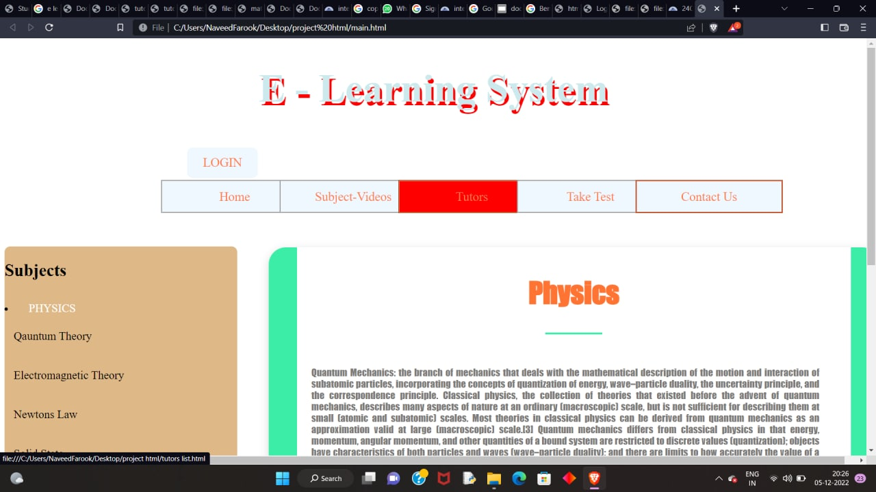

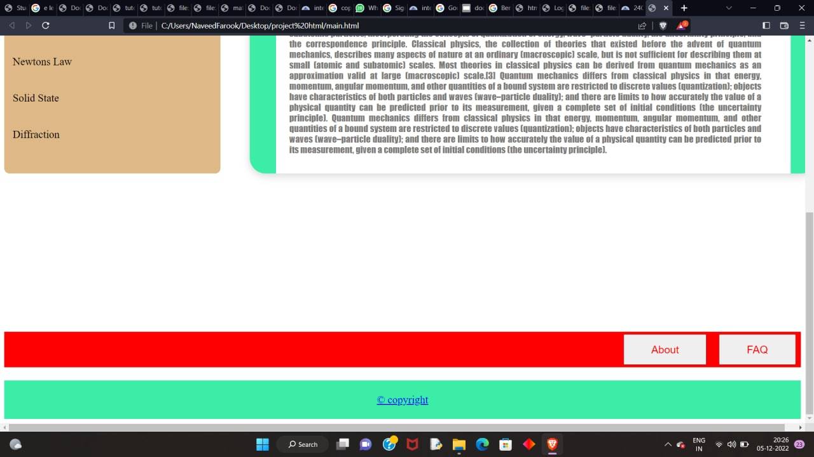

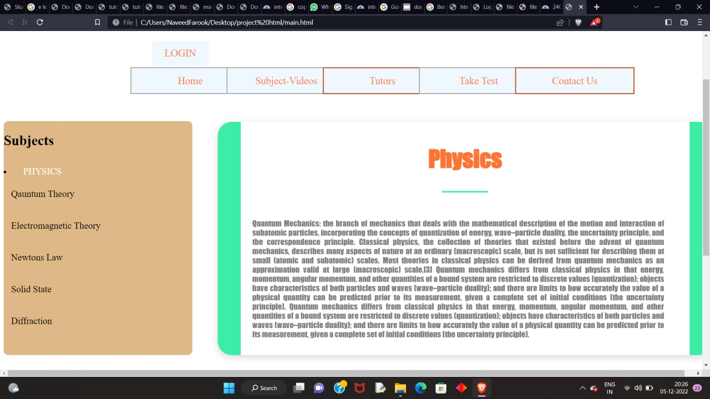

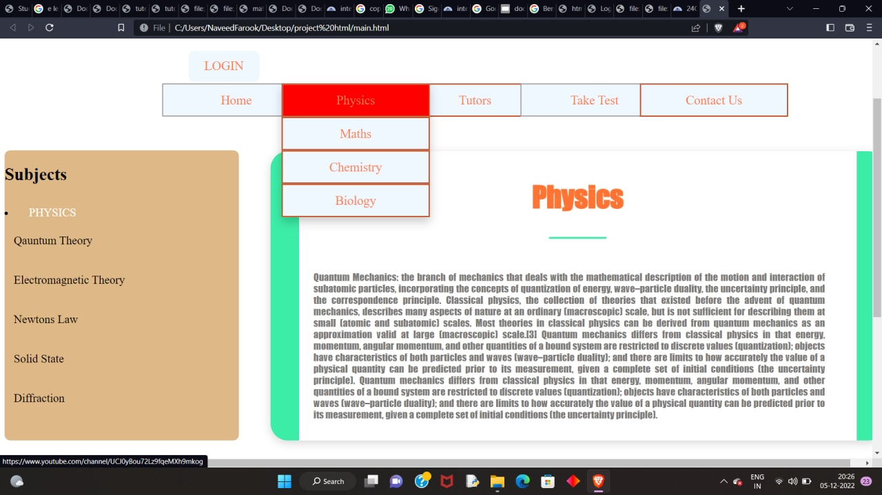

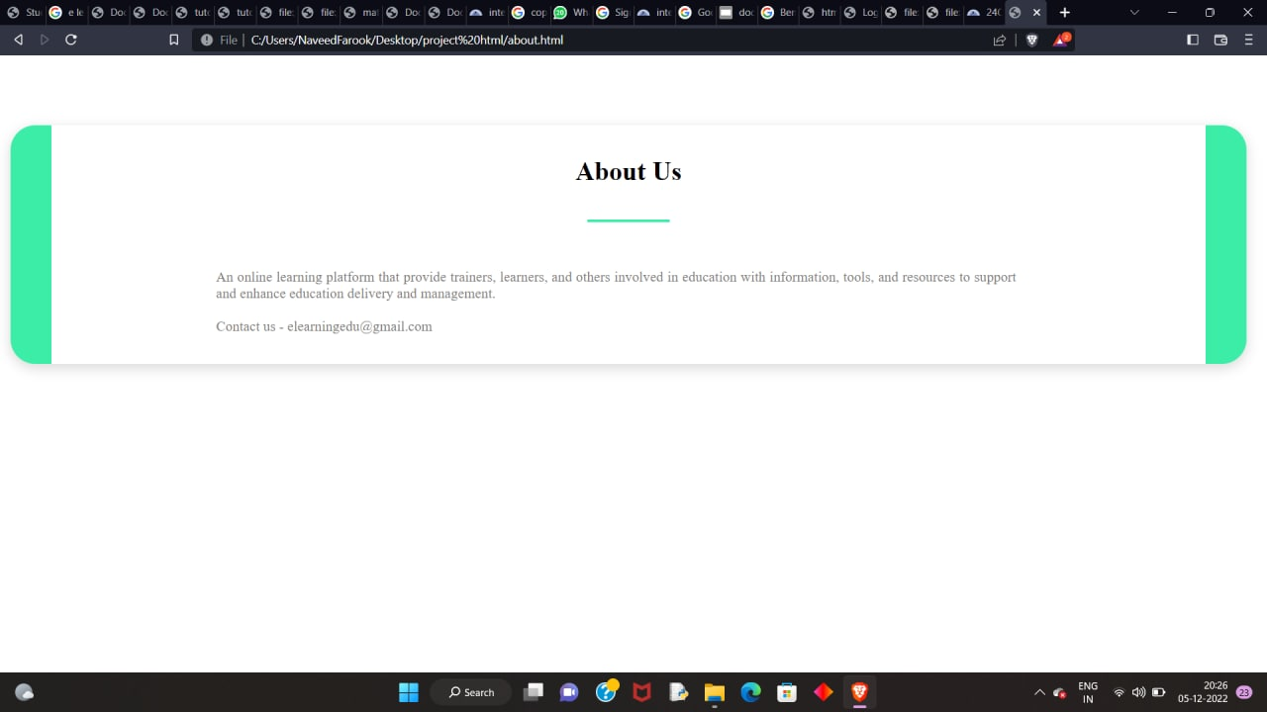

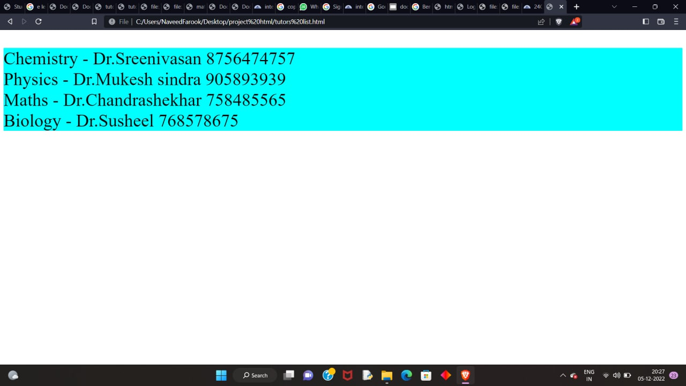

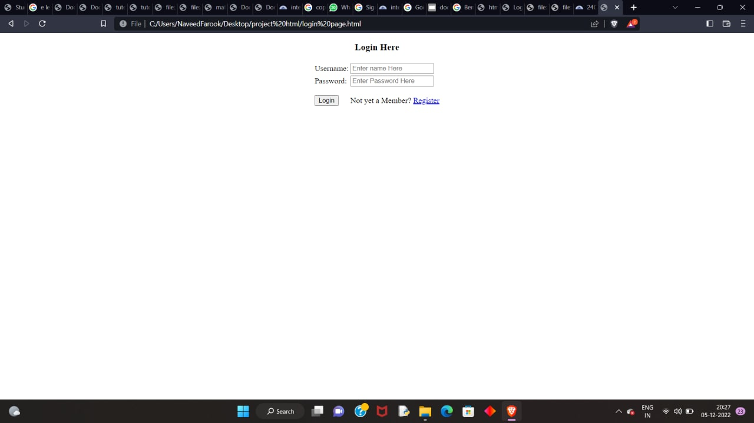

**LANGUAGES USED**

In the development of this website, we have used two languages.

They are:

* HTML
* CSS

**HTML:**  **HTML** (Hypertext Markup Language) is the most basic building block of the Web. It defines the meaning and structure of web content. Other technologies besides HTML are generally used to describe a web page's appearance/presentation (CSS) or functionality/behaviour (Java Script)

"Hypertext" refers to links that connect web pages to one another, either within a single website or between websites. Links are a fundamental aspect of the Web. By uploading content to the Internet and linking it to pages created by other people, you become an active participant in the World Wide Web.

HTML uses "markup" to annotate text, images, and other content for display in a Web browser. HTML markup includes special "elements" such as <head>,<title>, <body>,<header>, <footer>, <article>, <p>, <div>, <img>,<audio>, <video>, <ul>, <a>, <li>,<a>, and many others.

An HTML element is set off from other text in a document by "tags", which consist of the element name surrounded by "<" and ">".  The name of an element inside a tag is case insensitive. That is, it can be written in uppercase, lowercase, or a mixture. For example, the <title> tag can be written as <Title>, <TITLE>, or in any other way.

**CSS: C**ascading **S**tyle **S**heets, fondly referred to as CSS, is a simple design language intended to simplify the process of making web pages presentable.

CSS handles the look and feel part of a web page. Using CSS, you can control the colour of the text, the style of fonts, the spacing between paragraphs, how columns are sized and laid out, what background images or colours are used, layout designs, variations in display for different devices and screen sizes as well as a variety of other effects.

CSS is easy to learn and understand but it provides powerful control over the presentation of an HTML document. Most commonly, CSS is combined with the markup languages HTML.

**CONCLUSION**

this Learning system is a platform that provide trainers,learners,learning materials and other involved in education with information,tools, and resources to support and enhance education delivery and management

The user can even login into the website through login menu and get a hands on various resources.

By this project I have learnt the uses of HTML , CSS while designing this website.

**BIBLIOGRAPHY**

**www.w3school.in**

**www.google.com**

**www.wikipedia.com**

**www.youtube.com**

thank you